SQL Report

1. KPI's REQUIREMENT
2. Total Revenue: The sum of the total price of all pizza orders.

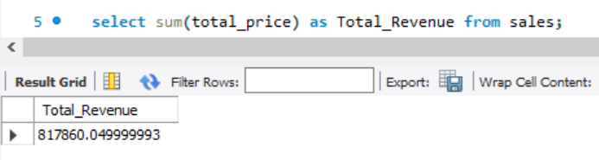

1. Average Order Value: The average amount spent per order, calculated by dividing the total revenue by the total number of orders.

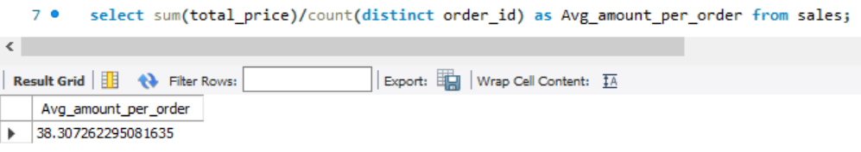

1. Total Pizzas Sold: The sum of the quantities of all pizzas sold.

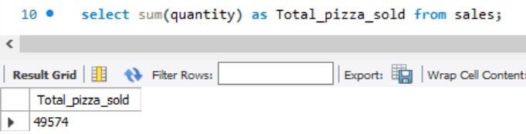

1. Total Orders: The total number of orders placed.

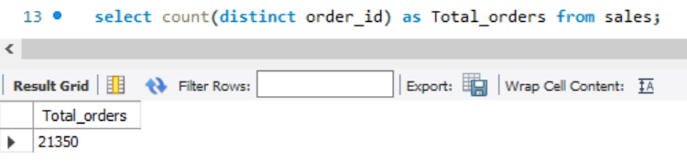

1. Average Pizzas Per Order: The average number of pizzas sold per order, calculated by dividing the total number of pizzas sold by the total number of orders.

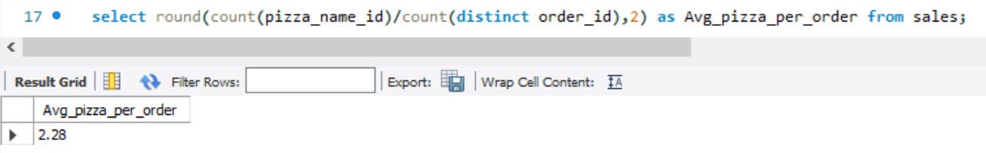

1. CHARTS REQUIREMENT
2. Daily Trend for Total Orders

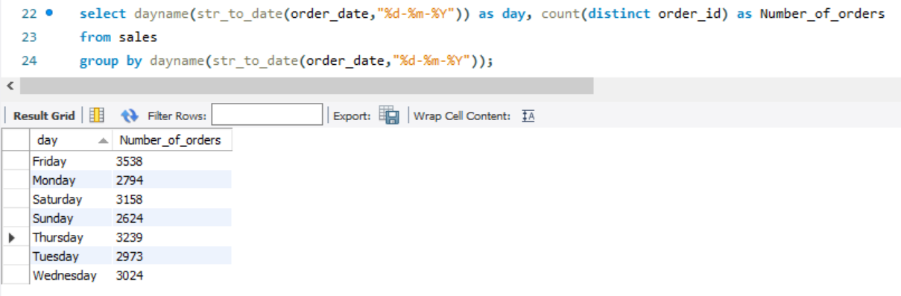

1. Monthly Trend for Total Orders

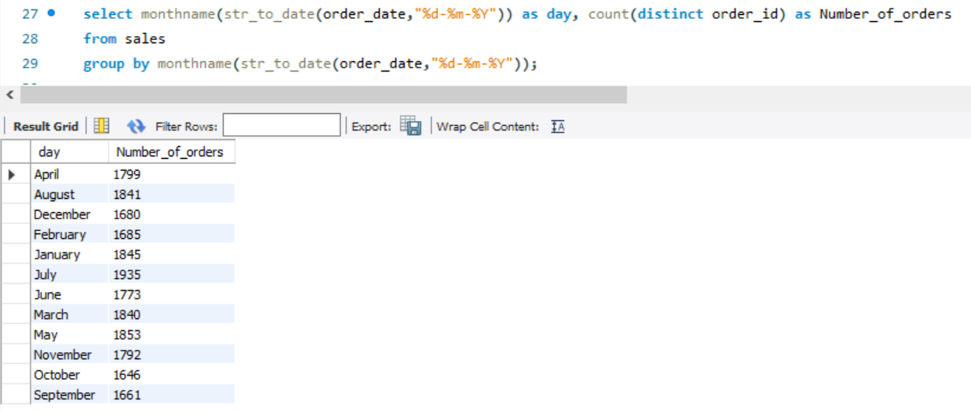

1. Percentage of Sales by Pizza Category

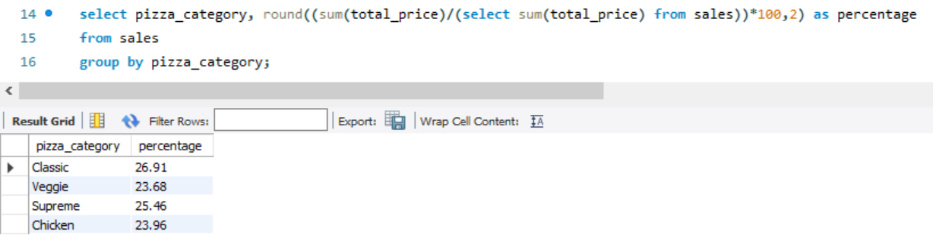

1. Percentage of Sales by Pizza Size

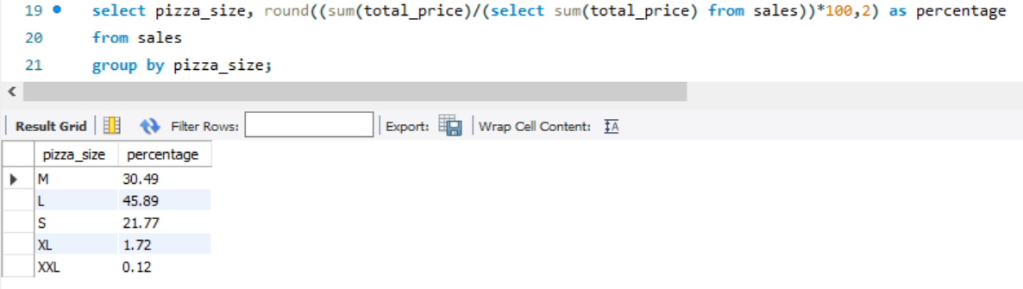

1. Total Pizzas Sold by Pizza Category

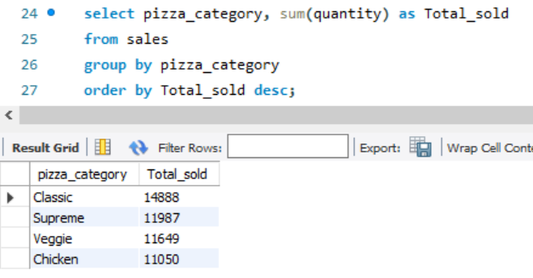

1. Top 5 Best Sellers by Revenue

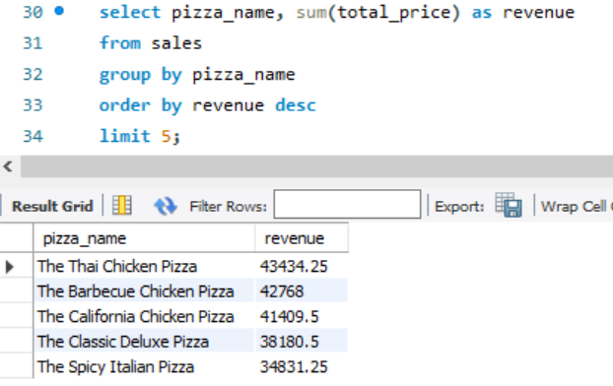

1. Bottom 5 Best Sellers by Revenue

